Working with Range Poles
Pole A range pole (also called a lining rod) is a metal or wood pole, usually about 2 metre long and about 20 mm in diameter; it is provided with a steel point or shoe and painted in alternate bands of red and white to increase its visibility. The range pole is held vertically on a point or plumbed over a point, so the point may be observed through an optical instrument. It is primarily used as a sighting rod for either linear or angular measurements.
Setting out straight lines over a short or long distance 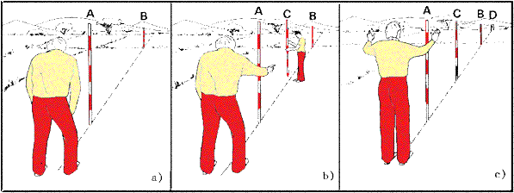

Optical square

A small hand instrument used in setting off a right angle. The optical square that we use has two plane mirrors placed at an angle of 45° to each other. Two range poles are placed on a chain line at position A and B. Range pole A should be seen in the lower mirrow, and the range pole B in the upper mirrow. Move range pole C (middle slot) in left or right direction until its lineed up with the range pole in the lower and upper mirrow. The lines to the point of observation from the two observed objects will then meet in a right angle.
( In another form of optical square, a single plane mirror makes an angle of 45° with a sighting line. it used for stting out a right angle.)

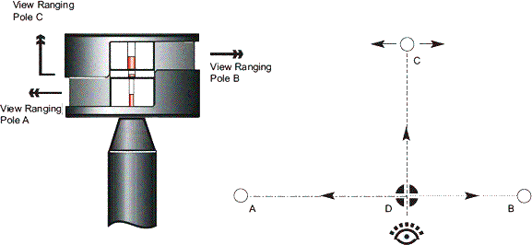

Setting out a perpendicular line with an optical square

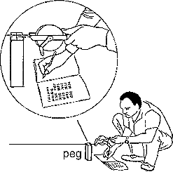
This method is used in Exercise 1 to set out a retangular building.

Two ranging poles are place on the chain line. Not too far from the offset station. In our example the perpendicular offset will be at Station 12083. A right angle has to be set out from the Station at C (12083). Move along the chainline until the plumb bob, which should be attached to the opticle square, points exactly at 12083. Use a range pole to set out a right angle. Measure the offset 6895 from Sstation C on the chain line and place a peg position D as shown in the below and opposite figure.
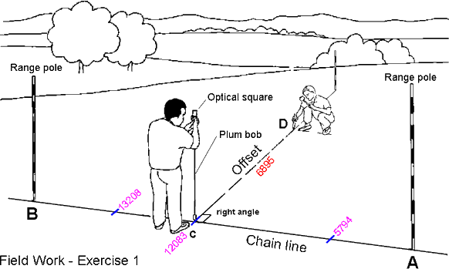

Coordinates
In order to describe the position of a point, two coordinates are required. Polar coordinates need a line and an angle. Cartesian coordinates need two lines within an orthogonal system. The total station measures polar coordinates; these are recalculated as Cartesian coordinates within the given orthogonal system, either within the instrument itself or subsequently in the office.

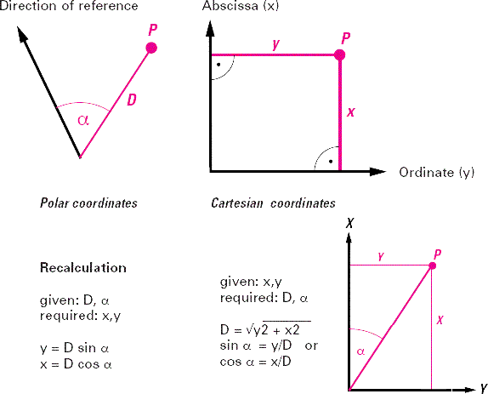
Offset calculation exercise

Calculate the area and perimeter of the Lot
A chain line (line & figures = red) is set up across an existing polygonal shaped lot running from Station A to Station B with given measurements along the chain line as well as the offsets (lines & figures = green) measurements to all other corner pegs of the lot.

From the given survey data find the area in square metre (three decimals) of the lot and the perimeter in mm (running metre of fencing).

As can be seen all single areas a to i consist of triangle and Trapeziums.

To calculate the area you only need to know the following formula:

(a) tringles and
(b) trapeziumsis

All offset measurements are perpendicular to thwe chaine line

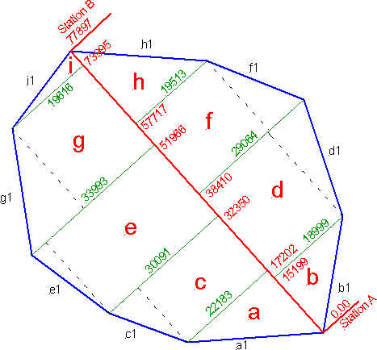

The area of Triangle a is 17.202 × 22.183/2 = 190.796 m²

Triangle b is 15.199 × 18.999/2 = 144.383 m²

The area of Trapesium c is (30.091 + 22.183)/2 × (32.350 - 17.202) = 395.923 m²

Trapezium d is (29.064 + 18.999)/2 × (38.410 - 15.199 = 557.795 m²

Finish the calculation for the rest of the areas (answer = 3,212 m²)

The calculation of the perimeter of the lot is more cumbersome. You may use either Pythagoras theorem or the trigonomich functions.

Pythagoras
length of a1 = √ (17.202² + 22.183²) = 28.071 m
b1 = √ (15.199² + 18.999²) = 24.330 m
c1 = √ [(32.350 -17.202)² + (30.091 - 22.183)²] = 17.088 m
d1 = √ [(38.410 -115.199)² + (29.064 - 15.199)²] = 18.783 m

Finish the calculation for the rest of the baundry sites (answer = 210.707 m)

Tigonometric functions
You may also use the trigonometric function to calculate the perimeter.

